EXPT NO:3 | CLEANSE DATA BY HANDLING MISSING VALUES, OUTLIERS, AND INCONSISTENCIES USING TABLEAU AND POWERBI
DATE: 10.07.2026

PRE-LAB QUESTIONS (PROVIDE BRIEF ANSWERS TO THE FOLLOWING QUESTIONS)
- What are the potential impacts of missing values in a dataset, and what are some common strategies to address them in Tableau and Power BI?

Missing values can distort summary metrics such as averages, lead to incorrect trends, drop entire rows during joins, and skew statistical calculations. Common strategies include filtering out nulls, replacing missing text with "Unknown", imputing numeric values with mean or median via calculated fields, and using Tableau’s Data Interpreter or Power Query in Power BI.

- What is the importance of identifying and addressing outliers in a dataset? How can outliers affect data analysis and model performance?

Identifying outliers prevents extreme or anomalous values from heavily skewing summary statistics and model training. Outliers pull the mean away from the true center, artificially increase variance, degrade predictive model accuracy, and distort trendlines on visual charts.

- What types of data inconsistencies might you encounter during data cleansing, and how can Tableau and Power BI help in resolving them?

Inconsistencies include text casing and synonym issues like "South Region" versus "South", trailing whitespaces, incorrect data types, or inconsistent date and currency formats. Tableau resolves them using Aliases, Groups, and Calculated Fields, while Power BI utilizes Power Query features like Replace Values, Split Column, Capitalize Each Word, and Format Changes

- How do you identify patterns in data using visualizations to spot missing values, outliers, and inconsistencies?

Missing values are identified using null indicators on charts or highlighted via profile views in data preparation tools. Outliers are easily spotted using Box Plots where points sit beyond whiskers or on Scatter Plots as isolated extreme points. Inconsistencies are identified using Histograms or distinct value listings in frequency tables to spot near-duplicate text entries or unexpected categories.
- What is the role of calculated fields in data cleansing, and how can they be used to handle missing values and outliers in Tableau/Power BI?

Calculated fields allow users to apply custom conditional logic to transform, clean, and standardize data dynamically without altering raw underlying files. They handle missing values by replacing missing entries with default values using functions like IFNULL in Tableau or ISBLANK in Power BI. For outliers, calculated fields apply cap or threshold rules to trim extreme values beyond reasonable bounds.

IN-LAB EXERCISE:
OBJECTIVE:
To clean a given dataset (e.g., Superstore Sample in Tableau and Financials/Sales Data in Power BI) by identifying and resolving missing values, outliers, and inconsistencies using built-in tools, ensuring the dataset is accurate and ready for analysis.

PROCEDURE:

Open the Tool and Connect Dataset
    - Open Tableau Desktop , Power BI Desktop.
    - Load the built-in dataset (Sample - Superstore in Tableau / Financials in Power BI).
    - Preview the dataset to understand its structure.

Initial Inspection
    - Explore fields such as Sales, Profit, Region, or Product Category.
    - Check for nulls, inconsistent text values (e.g., "South Region" vs. "South"), or date formatting issues.

Handling Missing Values
    - Use Data Interpreter (Tableau) / Power Query (Power BI) to highlight nulls.
    - Replace missing numerical values with mean/median, and text with "Unknown".
    - Use calculated fields: IFNULL([Field], Default) in Tableau or IF(ISBLANK([Field]), "Unknown", [Field]) in Power BI.

Detecting and Managing Outliers
    - Create scatter or box plots for Sales and Profit to identify extreme values.
    - Choose strategies:
      - Filter them temporarily.
      - Apply caps using calculated columns.

      - Flag them with labels for review.

Resolving Inconsistencies
    - Use Group/Alias (Tableau) / Replace Values (Power BI) to standardize text.
    - Normalize data formats, such as date fields or currency units.

Validation with Visuals
    - Build dashboards with histograms, bar charts, and box plots to visually confirm improvements.
    - Compare before/after cleaning stages for accuracy.

Save the Cleaned Dataset
    - Save as .twbx (Tableau) / .pbix (Power BI).
    - Optionally export cleaned data to .csv.

Summary Dashboard
    - Create a visual summary of the cleaning process, highlighting:
      - Fields corrected.
      - Nulls/outliers removed or adjusted.
      - Clean dataset metrics (record count, completeness %).

Experiment Dataset:
- Tableau: Sample - Superstore
- Power BI: Financials or Sales Data

How to Access:
Tableau:
  - Navigate to: Start Page → Sample Workbooks
  - Or: Help → Sample Data → Open Sample Data Folder

Power BI:
  - Navigate to: Home → Get Data → Excel → Choose sample datasets (e.g., Financial Sample.xlsx)
  - Microsoft also hosts Power BI sample datasets online.

Fields Used:
- Sales
- Profit
- Region
- Category

- Order Date / Transaction Date
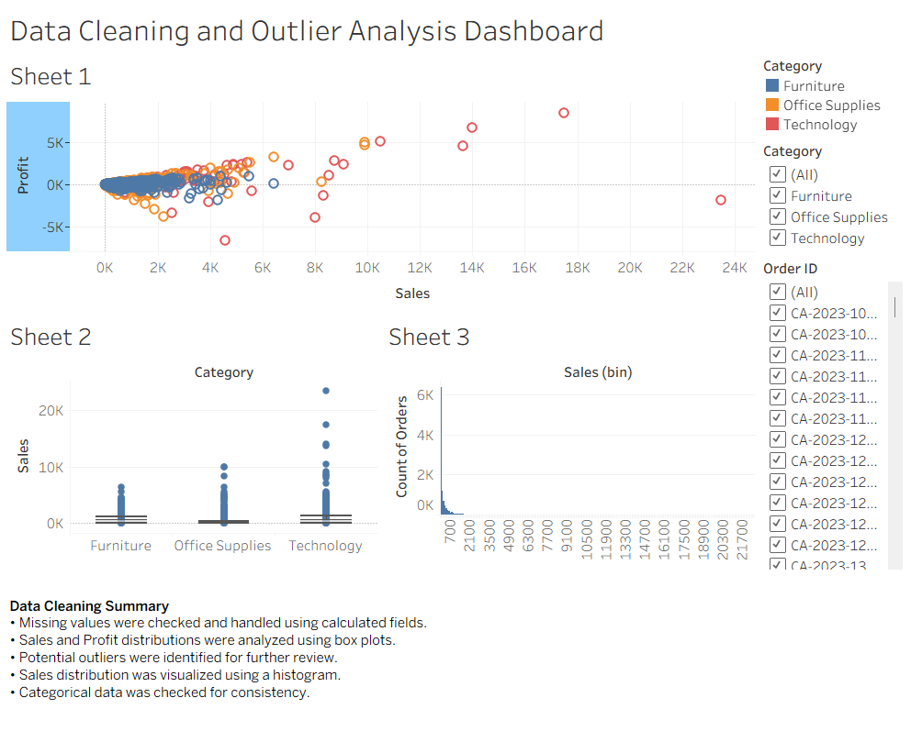
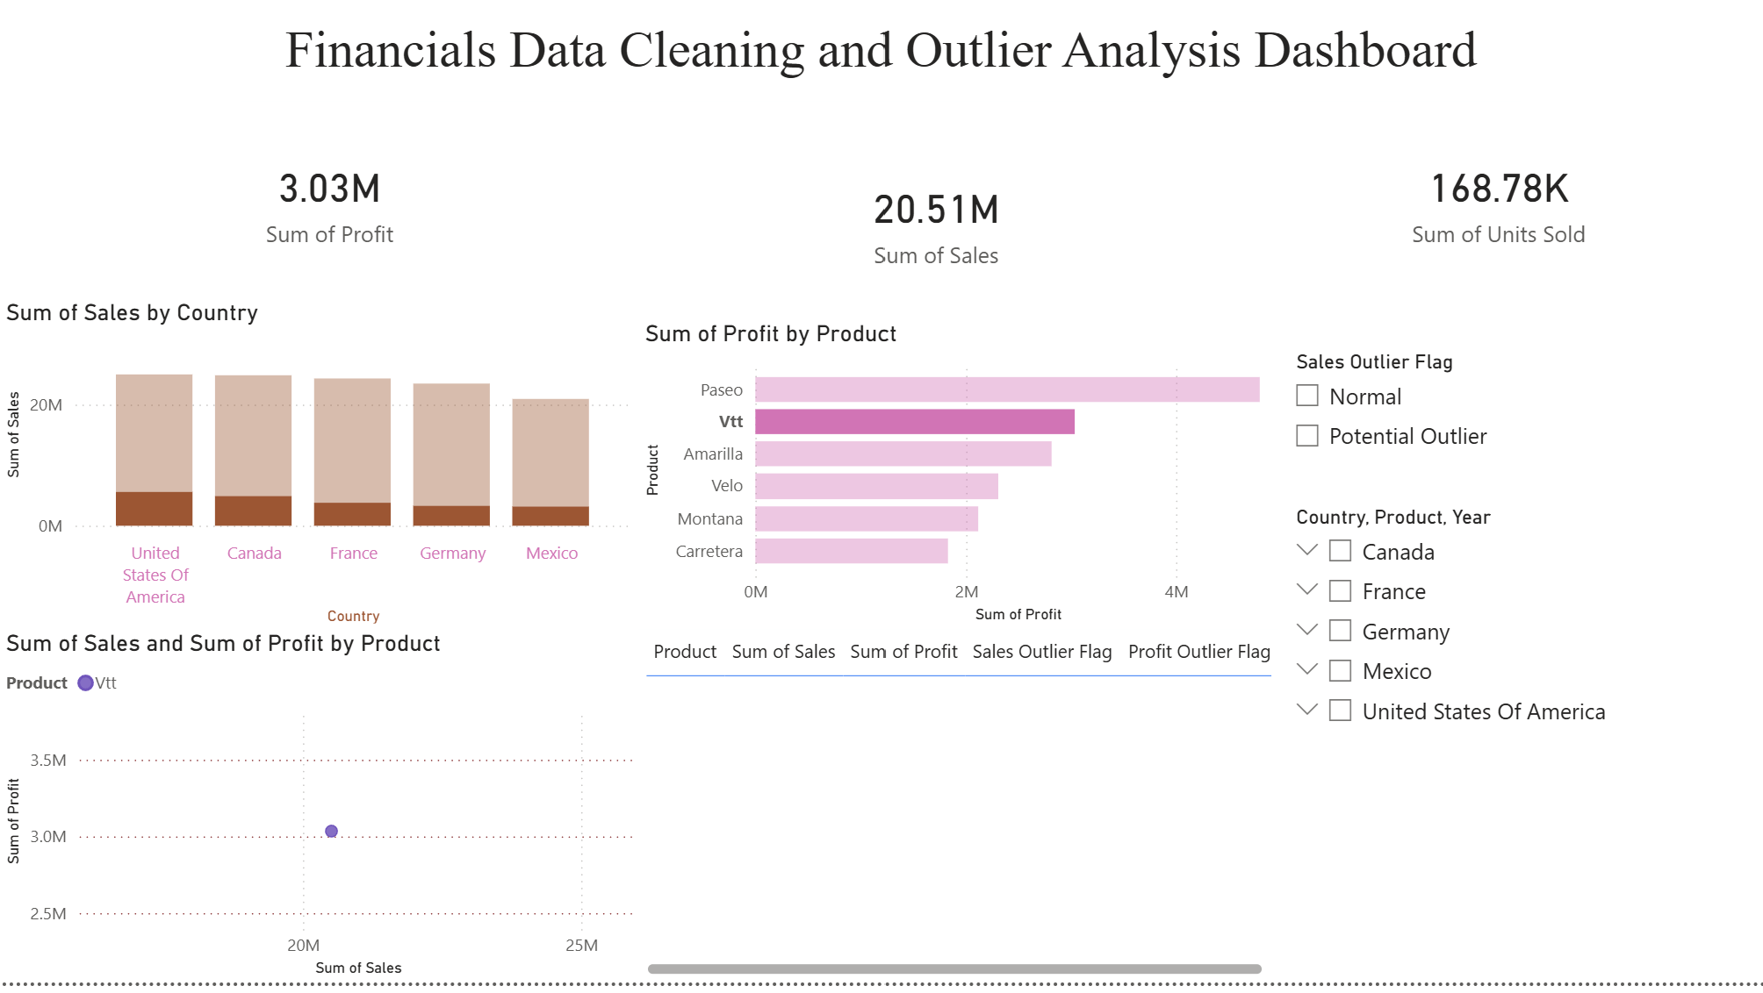

POST-LAB QUESTIONS (PROVIDE BRIEF ANSWERS TO THE FOLLOWING QUESTIONS)
- What method did you use to replace missing values in numeric fields?

Numeric missing values were replaced by imputing either the mean or median value, or replacing nulls with zero using calculated fields such as IFNULL in Tableau, or using Power Query's Replace Values feature in Power BI.

- How were outliers handled in your dataset and what visual confirmed their correction?

Outliers were detected using Box Plots and Scatter Plots for Sales and Profit, and were handled by filtering them out or applying numerical caps via calculated fields. Corrected Box Plots and Histograms confirmed their adjustment by displaying controlled data distribution bounds without extreme isolated points

- What inconsistencies were detected in categorical values and how were they standardized?

Variations in naming formats like regional name discrepancies and casing issues were detected. In Tableau, these were standardized using Aliases and Grouping, while in Power BI, they were resolved using Power Query's Replace Values and text transformation functions.

- Describe how calculated fields helped in resolving data issues.

Calculated fields provided conditional rules to systematically detect and resolve nulls, flag or cap extreme sales numbers beyond reasonable limits, and merge split text categories into unified standard values.

- How did your dashboard demonstrate the effectiveness of the data cleaning process?

The summary dashboard provided a clear visual before-and-after comparison, highlighting key completeness metrics such as total record count, 100 percent data completeness percentage, zero remaining nulls, and clean distribution charts free from severe outlier distortion.

RESULT:

The dataset was successfully cleaned and prepared for accurate analysis using Tableau and Power BI. Issues such as nulls, inconsistencies, and outliers were identified and resolved, improving data quality significantly.

Github Repo - > https://github.com/tharun2128/24ADC001--BUISNESS-INTELLIGENCE

ASSESSMENT

Description | Max Marks | Marks Awarded
Pre Lab Exercise | 5
In Lab Exercise | 10
Post Lab Exercise | 5
Viva | 10
Total | 30
Faculty Signature

